- Following Wednesday's UK Budget, gilt yields have risen sharply as financial markets appear concerned over the scale of the extra borrowing, that some of it will fund current spending rather than investment, and the narrow headroom it leaves.
- These valid concerns suggest spreads may remain elevated, but we don’t expect them to widen. The government will still tighten fiscal policy and has replaced implausibly tight spending assumptions with tax hikes, which we think is a more credible plan. Shorter timeframes for the fiscal rules should bolster that credibility.
- Repricing at the shorter end of the curve means markets now expect fewer rate cuts next year. This is a response to the Office for Budget Responsibility's view that the package will offer a sizeable boost to growth next year. But we think the OBR is too optimistic on the growth impact.
Despite the UK government's efforts to prepare the ground over the past few months, financial markets reacted badly to Wednesday's Budget. On Thursday afternoon, the 10-year gilt yield spiked 35bps higher than when Chancellor Rachel Reeves began her Budget speech. Yields have remained very volatile over the past day, and on Friday afternoon 10-year yields were still around 30bps higher. Spreads have widened against US Treasuries and particularly German bunds. (Chart 1).
Though the market's allergic reaction is unwelcome for the new Labour government, the response has been much more muted than after the Conservative's mini-Budget of September 2022. Then, 10-year gilt yields spiked 50bps in the two days after the Budget and were up 90bps after a week. What's more, the rising yields in the 2022 episode were accompanied by a sharp depreciation in sterling. This time, the initial fall in the value of sterling has been much smaller and had mostly reversed by Friday afternoon.
Chart 1: Gilt yields have risen sharply since the Chancellor presented her Budget
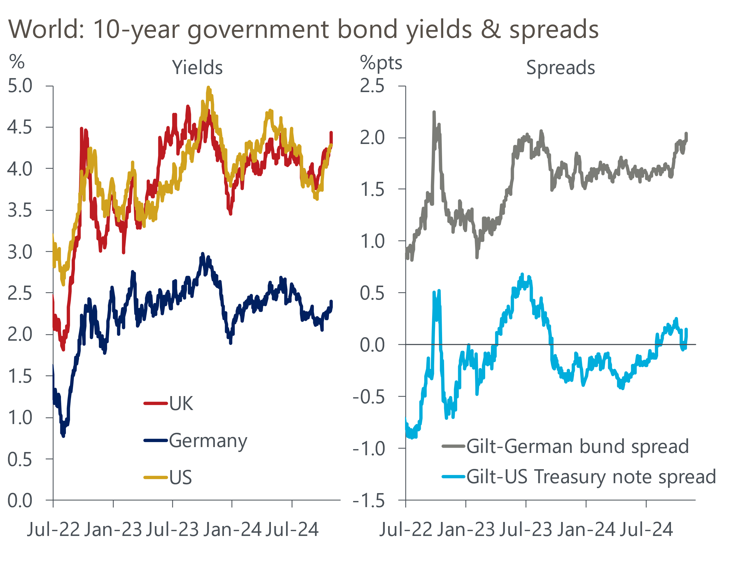
Source: Haver Analytics

Some of the market reaction reflects the expected impact on monetary policy. The Office for Budget Responsibility estimates that higher current spending will provide a substantial boost to GDP growth in 2025-2026. Markets have taken this at face value and assume it will be offset by tighter monetary policy. As of market close on October 31, market expectations for Bank Rate at the end of 2025 were 25bps higher than they were before the Budget (Chart 2).
Chart 2: Markets think looser fiscal policy will mean fewer Bank Rate cuts
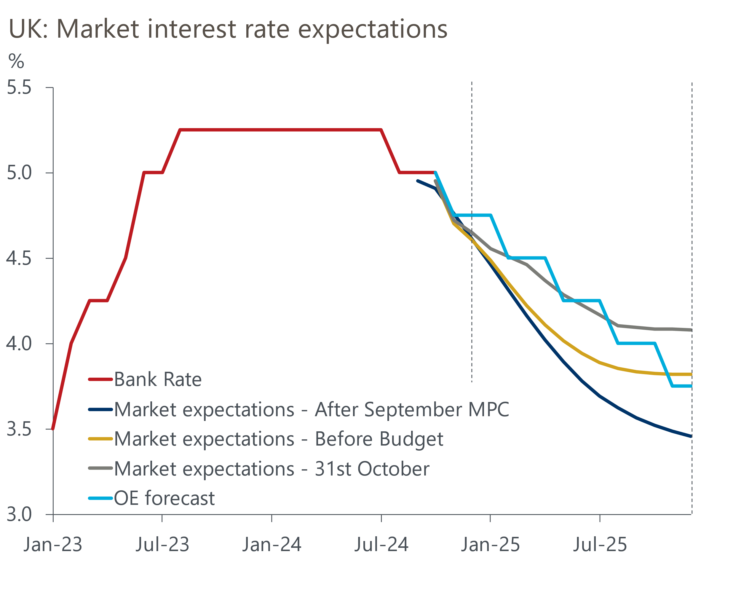
Sources: Oxford Economics, Haver Analytics
In our view, however, the OBR is too optimistic about the extent to which higher current spending will boost GDP. Much of the increase comes from higher real government consumption, but higher public sector wages also accounts for some of the increase. The way that public sector output is measured also makes us sceptical that output will be boosted to the extent expected.
Furthermore, recent OBR forecasts for real government consumption have tended to prove over-optimistic, with the starting point for the subsequent forecast typically lower than had been projected (Chart 3). We expect the boost to GDP growth to be much smaller and largely offset by the impact of higher employers' national insurance contributions.
Chart 3: The OBR's recent forecasts for government consumption have proven too optimistic
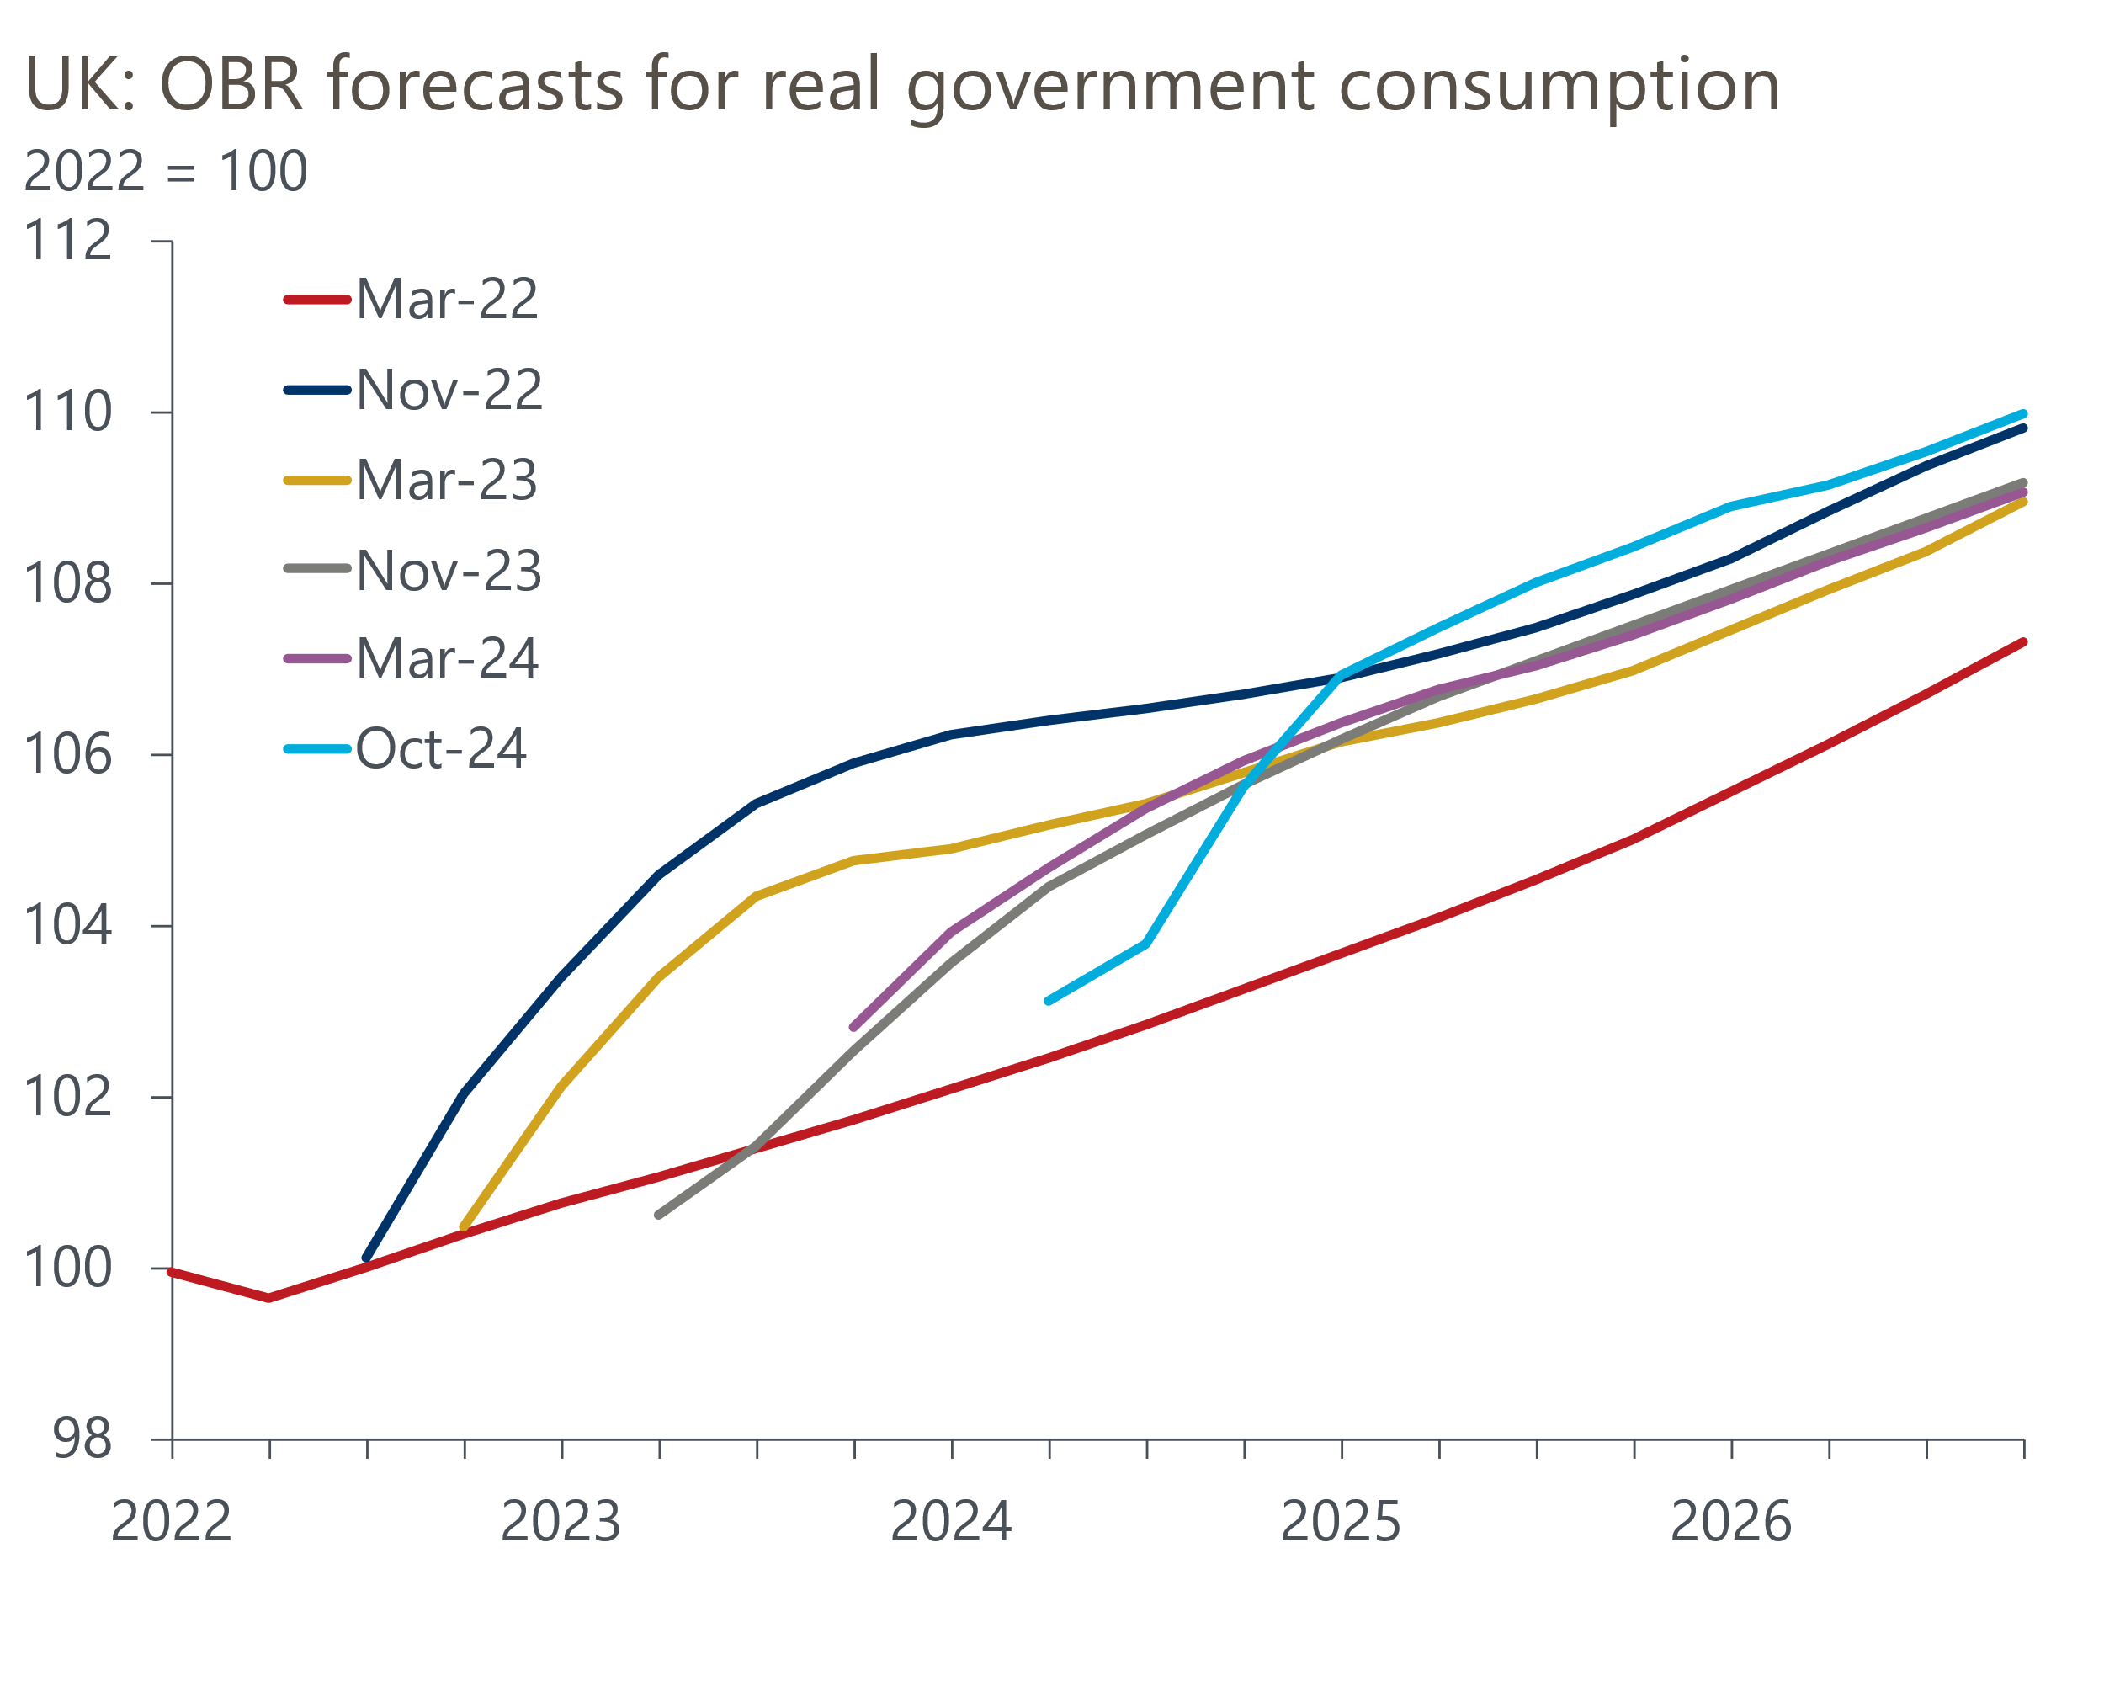
Source: Oxford Economics calculations using forecasts from Office for Budget Responsibility
Consequently, we still expect the Monetary Policy Committee to cut Bank Rate by 25bps next week, and to cut rates significantly during 2025.
We attribute the rest of the increase in yields to several aspects of the Budget that have made markets more cautious:
- Size of the package. The government's messaging had led markets to believe the Chancellor would adopt looser fiscal rules and borrow more. But media speculation had centred on a smaller package, with the extra borrowing expected to be closer to £20bn a year rather than the £30bn-£40bn a year increases that were announced.
- Borrowing to fund current spending. Pre-Budget statements and the Chancellor's speech focused on the case for borrowing more to increase government investment. But close analysis of the Budget documents makes it clear that a third of the extra borrowing is to fund higher day-to-day spending.
- Lack of headroom against future shocks. Having adopted looser fiscal rules, we expected the Chancellor to try to mitigate any market concerns about fiscal profligacy by leaving much greater headroom. But in the event, Reeves left just a £10bn margin for error against the borrowing rule – a tight leeway similar to recent Conservative Budgets.
- Plenty of scope for borrowing to overshoot. The revenues to be generated by several of the tax increases are far from guaranteed. The OBR's potential output forecasts are still relatively bullish. And it will be very challenging to turn the departmental spending totals after 2025-2026 into concrete department-by-department plans when the government publishes next year's spending review. OBR calculations suggest the totals will mean real terms spending for unprotected departments will fall.
These valid concerns suggest that bond spreads may remain elevated for a while. But we believe the current situation is very different to 2022, when the Conservative government announced large tax cuts funded by extra borrowing that would have had little obvious impact on the UK's supply potential and were not backed by any modelling from the OBR.
This time around, the government has committed to a significant multi-year fiscal consolidation (Chart 4). In addition, though policy will be tightened by less than previous plans had implied, the consolidation looks more credible because implausible and unspecified spending cuts have been replaced by more concrete tax increases. The planned switch to a rolling three-year horizon for judging the fiscal rules – something that we've called for over the past few years – should also reinforce the credibility of the government's fiscal plans.
Chart 4: The government plans to tighten fiscal policy significantly
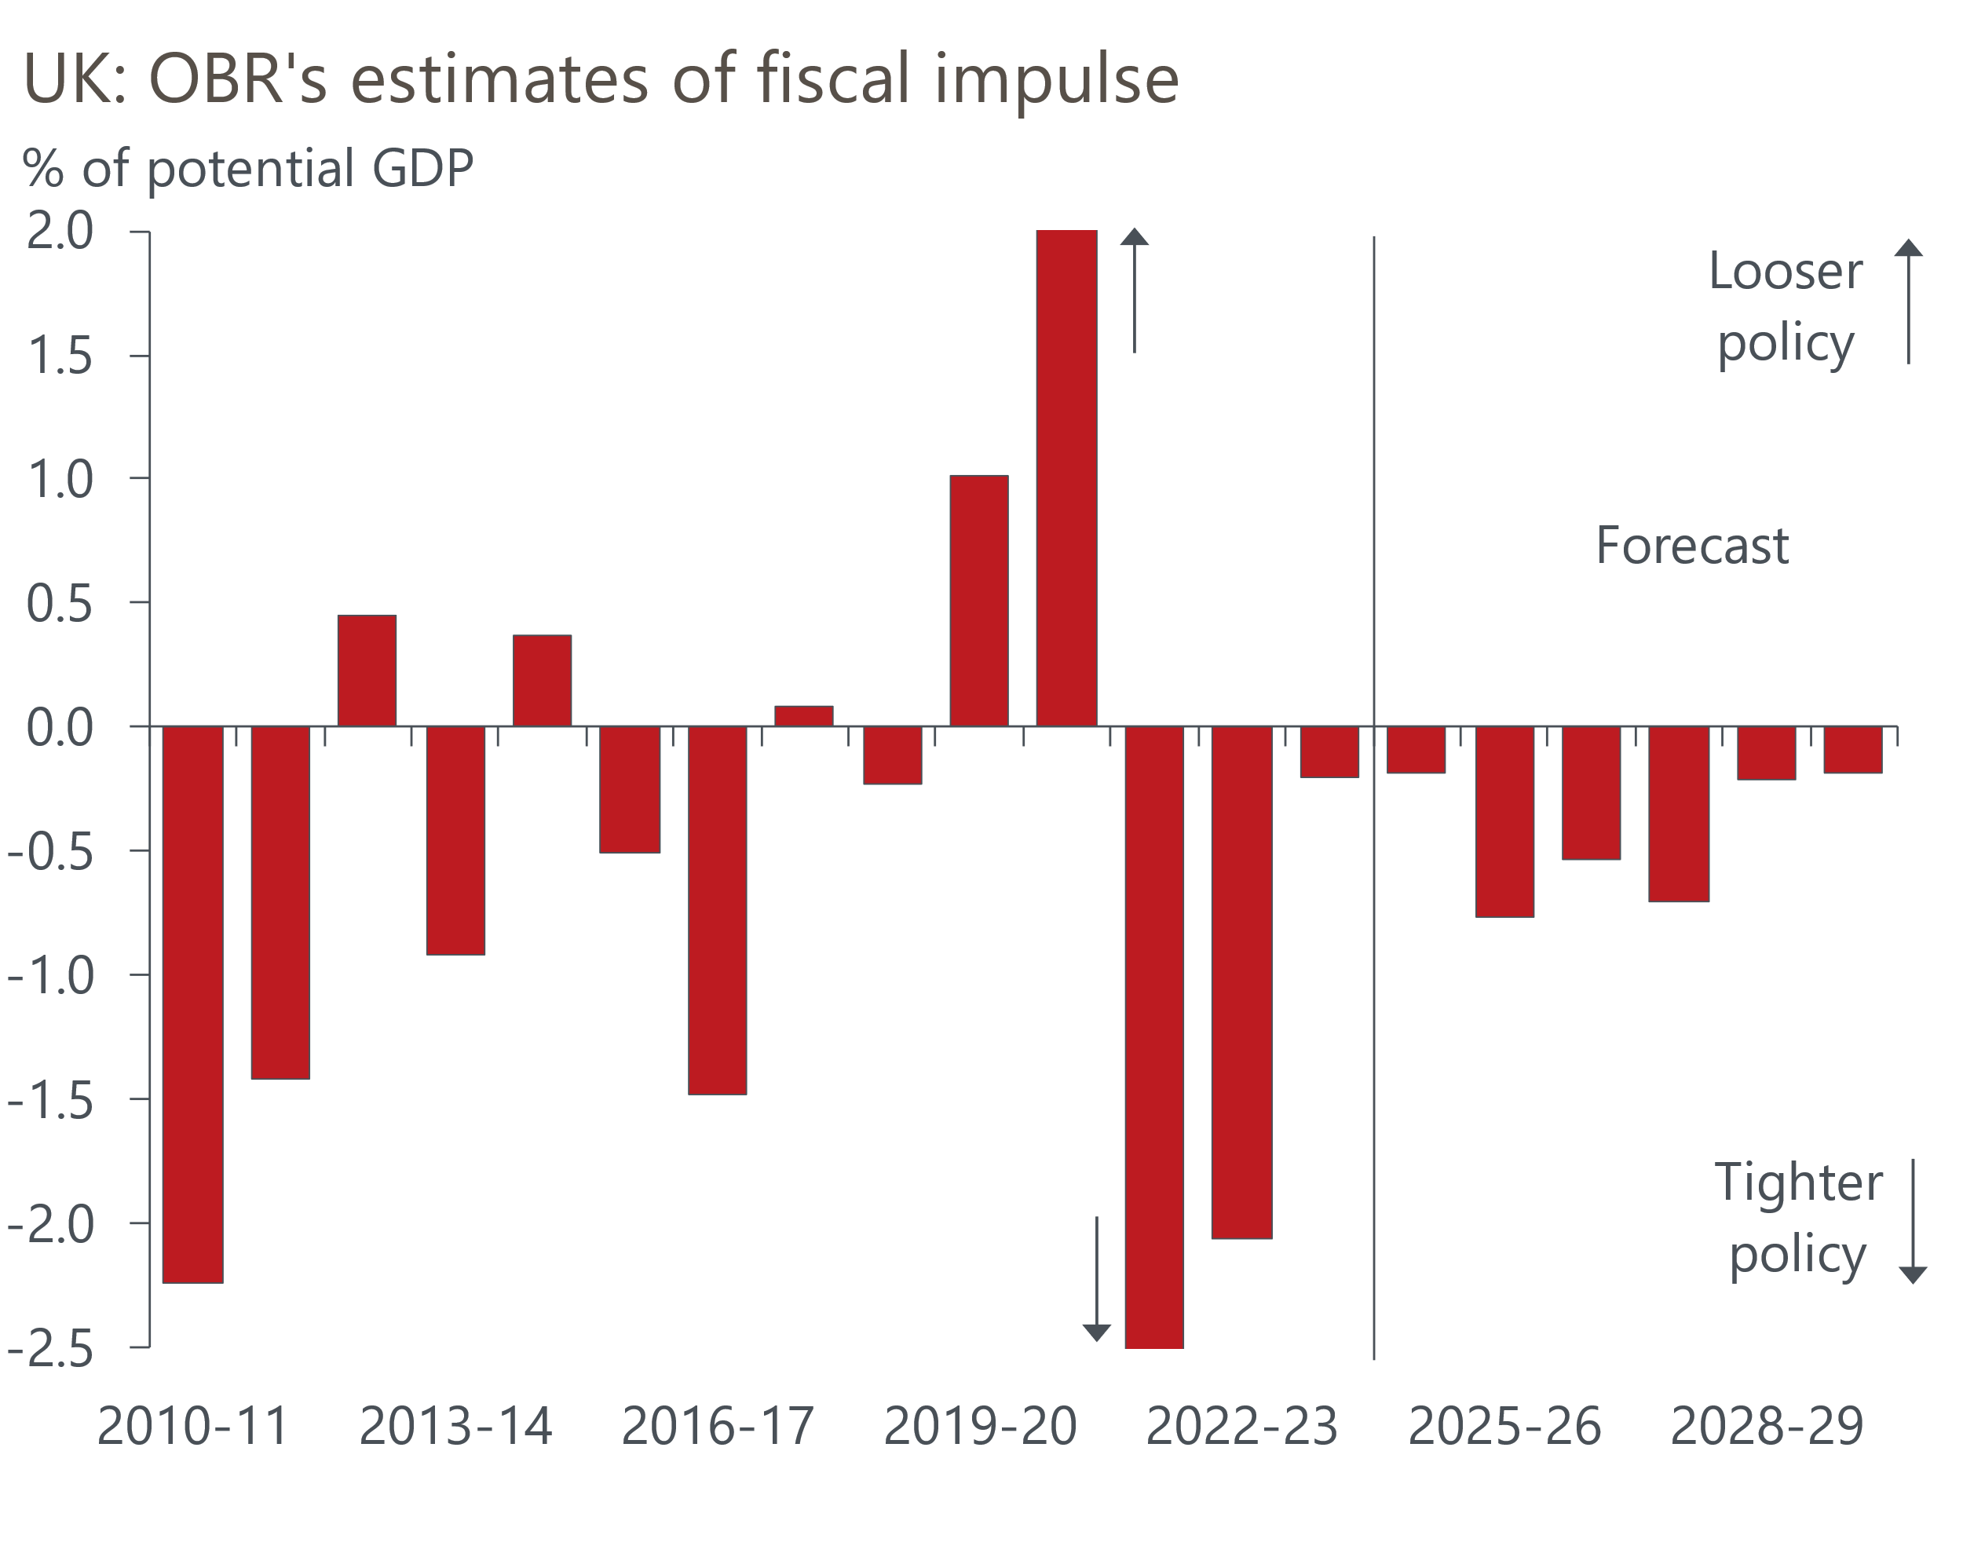
Source: Office for Budget Responsibility
In media interviews over the past day, Reeves has reiterated the importance of fiscal stability. If she makes clear that this includes addressing any slippage against borrowing forecasts with more tax hikes, that would provide some reassurance to markets and defuse the impetus for spreads to widen.

